**Applied Statistics - Lab 1**

**Date of performance:** 12-08-2021

**Date of Submission:** 13-08-2021

**SAP Id:** 500083382

**Name:** Anurag Singh

**Batch:** AI&ML B2

**___________________________________________________________________________**

**Topic:** Measure of central tendency - using Pandas

**Problem:** Read the file as a dataframe in python. List the type of data that each column represents. Finally, use the proper measure of central tendency for each. What do you think of the missing value?

**Dataset:**

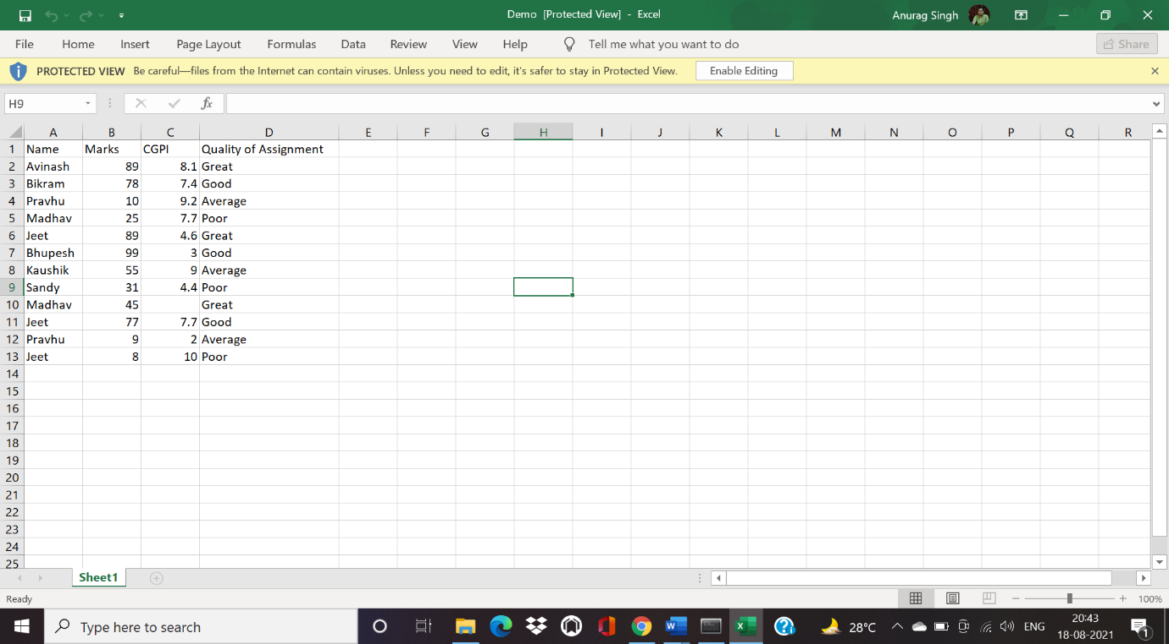

**Code to read the file as a data frame in Python:**

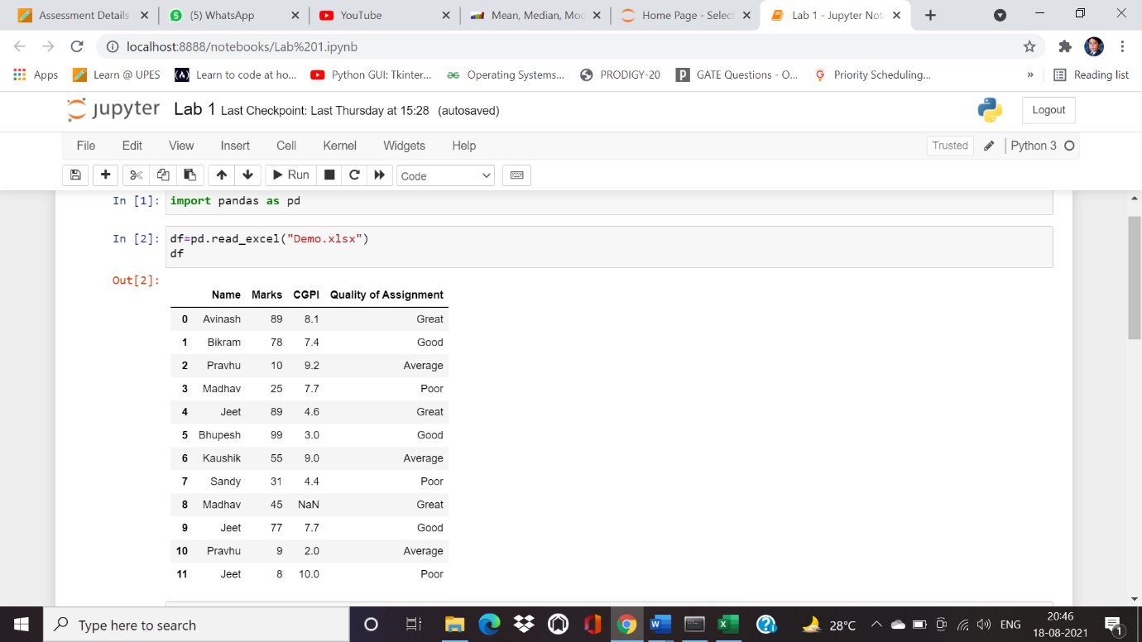

**Code to list the type of data of each column**

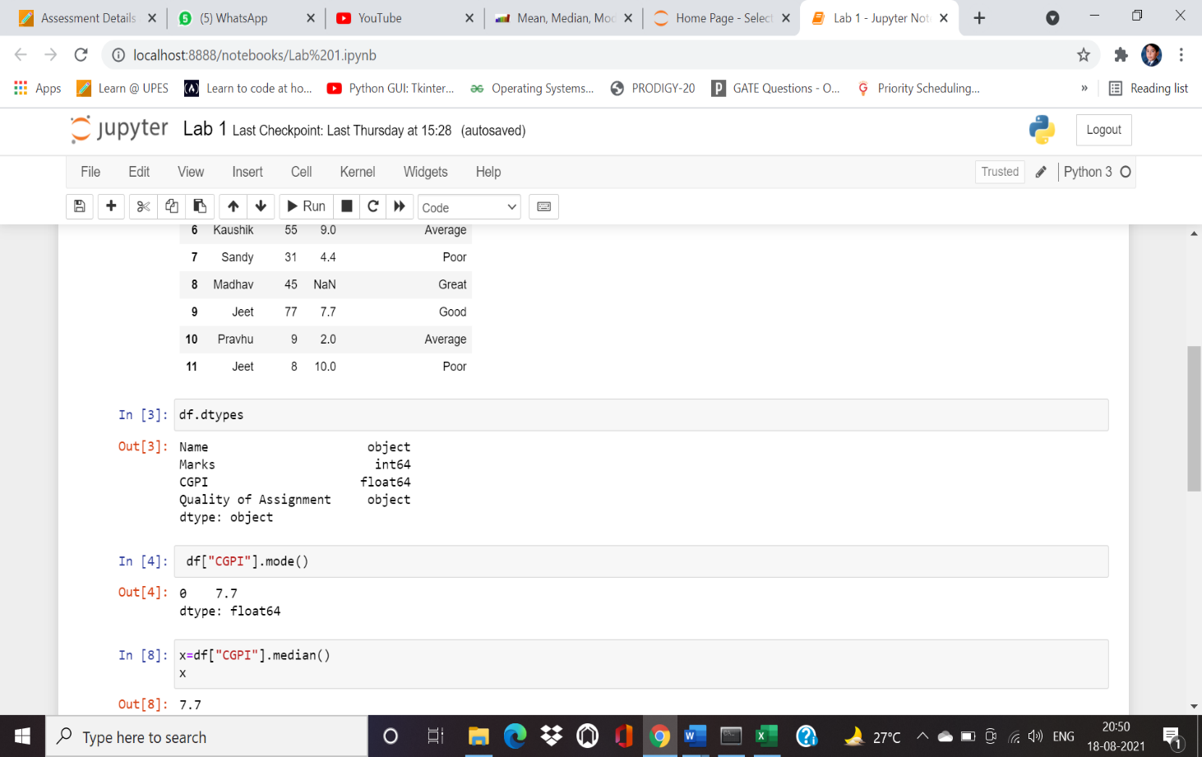

**Code to find mean median and mode and replace by sutiable central tendency**

